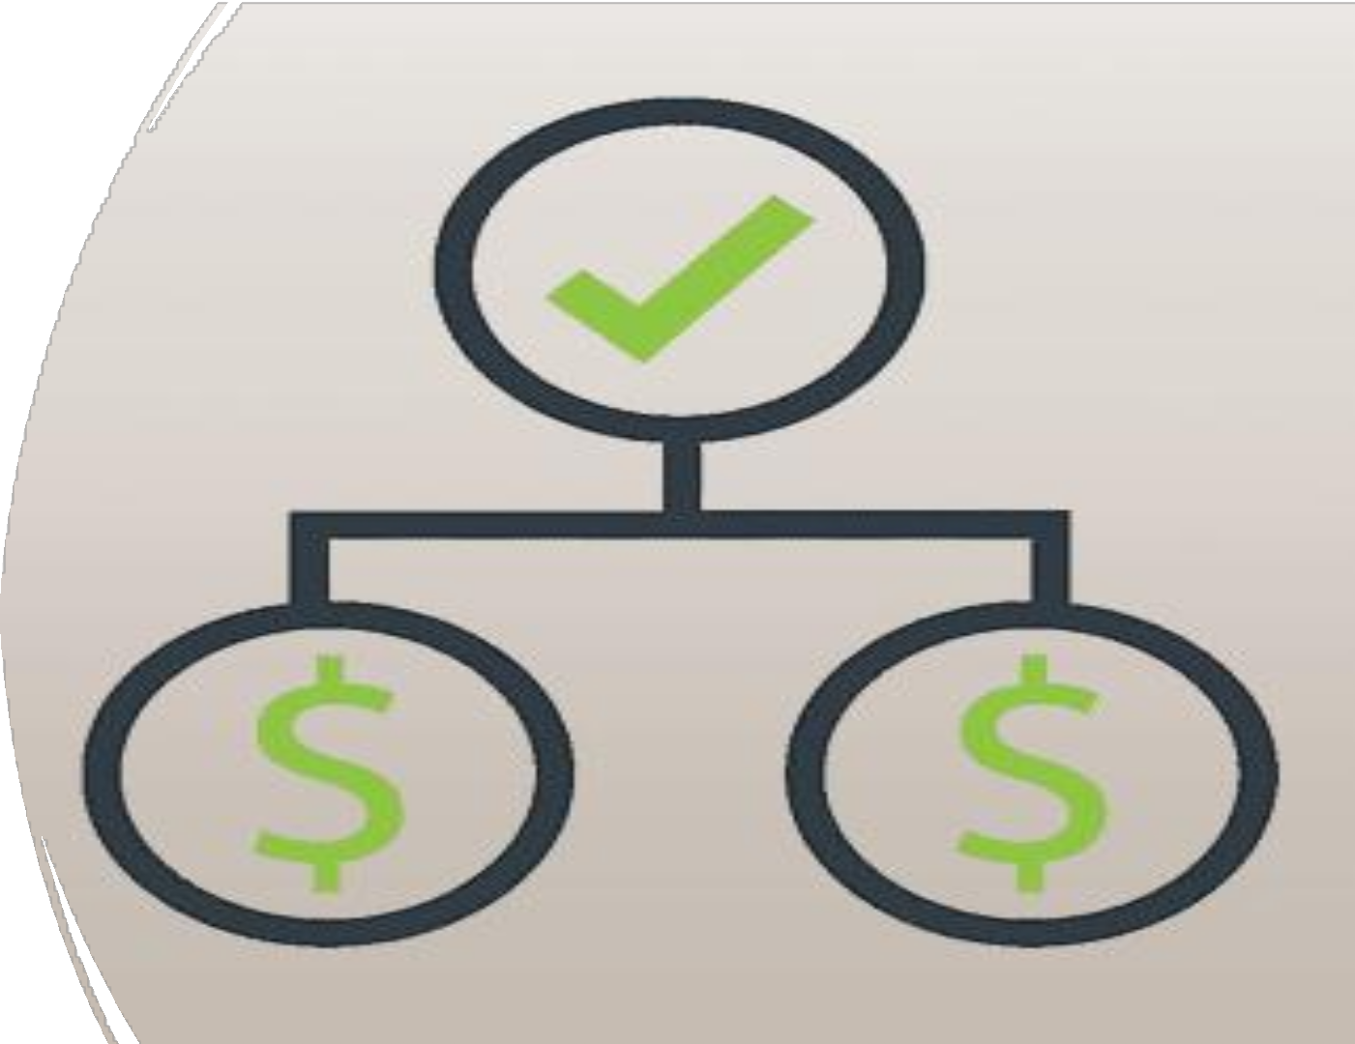

**Predicting Daily S&P 500 Movements Using Macroeconomic Indicators**

Team:

* Prathmesh D. Pawar
* Pratik More
* Rushikesh Shinde
* Sai Swetha Lakkoju
* Shikha A. Singh

Problem and Stakeholder

Develop a predictive model to determine daily upward or downward movements of the S&P 500 index by analysing key financial indicators.

Gold & Oil Prices Currency Exchange Rates Strength of US Dollar

Current models don’t account for the above mentioned key global economic factors leading to incomplete or less accurate predictions. By integrating these factors, our model can provide more comprehensive and accurate predictions.

Financial Analysts

Retail Investors



Corporate Leaders

FinTech Platforms

# Envisioned Solution - How our project meets stakeholder needs

To build a machine learning model to forecast daily S&P 500 movements by analysing the impact of gold and oil prices, currency exchange rates, and the U.S. dollar strength.

Investors can use these predictions to make informed decisions, timing their investments to capitalize on expected rises and avoid or mitigate losses during downturns.



Helps stakeholders to identify potential risks, enabling investors to adjust their strategies and hedge against factors that could negatively impact multinational companies in the index.



Enables investors to act on opportunities during favourable conditions and protect their assets

during unstable periods, optimizing their investment outcomes.

DATA OVERVIEW

* **Source :** All data is sourced from Investing.com

for the timeline [2016-2024].

* **Volume :** 2236 rows and 47 numerical columns (features).
* **Key Data Features:** Daily closing prices, high/low values during a trading day, volume i.e., number of shares traded in a day.
* **New Features Created:** Created a new target variable - binary movement [ target variable ] , a column indicating the movement of the S&P 500 index. -1 if the S&P 500 goes down, +1 if it goes up, 0 if it stays the same.

DATASETS USED :

 S&P 500 Futures

 Gold Futures

 Crude Oil WTI Futures

Exchange rate between Euro and US Dollar  Exchange rate between pound and US Dollar

 Exchange rate between Chinese yuan & US Dollar  Exchange rate between Japanese yen & US Dollar

US Dollar Index

Initial Results

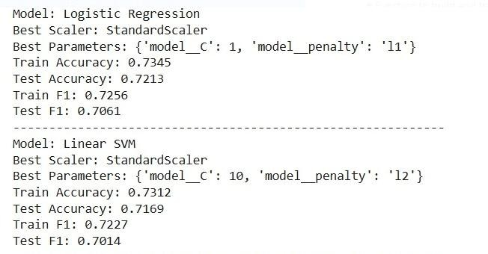

Challenges

**Imbalanced Target Variable**: Our target variable[ binary movement] is imbalanced



(more “-1"s compared to "+1" and ”0")

**SMOTE Limitation**: SMOTE can't be used effectively for time series data due to its risk of breaking temporal dependencies and introducing unrealistic synthetic samples.

**Overfitting of data:** We had common columns (Closing Price, % Change) across datasets which caused redundancy and overfitting.

# Plans & Goals

**Address Class Imbalance:** We want to explore alternative methods to handle the imbalanced target variable (class weighting, downsampling) which might be more suitable for our time series data.

**Incorporate More Models:** Our data is inherently sequential ( financial time series ). We want to try more models like XGB, Random Forest to see if we can better capture the patterns and improve performance.

Expand Dataset: We want to include more timeframe for the data and further improve model

generalisation.